**Assignment 3**

Based on the readings, lecture slides, and materials in the Module 2, answer the below questions and submit via blackboard in a .docx or .pdf format.

To perform this assignment, you will need to use the “Sakila” database that is pre-installed, just like we did in Module 1. Below is the first Entity Relationship Diagram (ERD) that we are going to use in this course. Note that there is a much larger diagram for this database, but for the sake of this assignment we’re going to start here to build foundational principles.

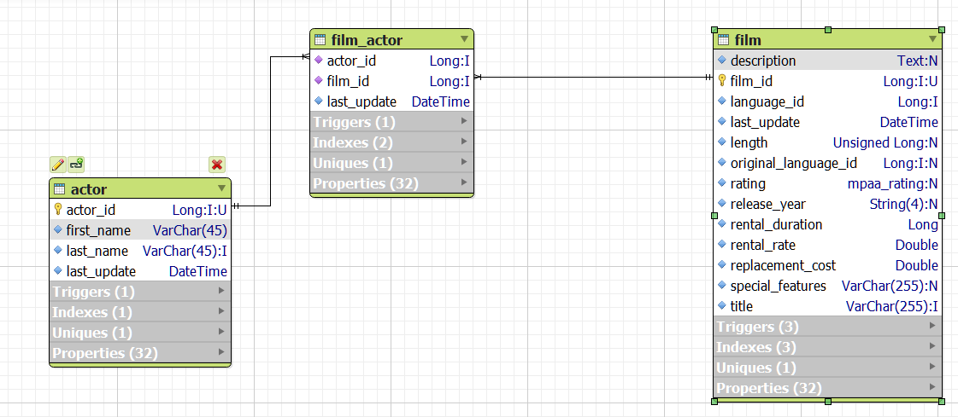

Within this database, you will be using the film, film_actor, and actor tables this assignment. Based on assignment readings and slides, perform each of the following queries from the fil table.

**Guided Queries: For the 5 following questions, your submission will be the query that you would write that would return the needed result**

1. Write a query that returns all columns from the film_actor table.

As in the diagram, the film_actor table has only three columns as actor_id, film_id & last_update.

Therefore, to get only that three columns, below will be the query.

**Select \***

**From film_actor**

1. Write a query that returns all columns from the film_actor and film table.

All columns relevant to both tables will be returned here

**Select \***

**From film JOIN film_actor ON film_actor.film_id = film.film_id**

1. Write a query that returns all columns from the actor and film_actor table.

All columns relevant to both tables will be returned here

**Select \***

**From Actor JOIN film_actor ON actor.actor_id = film_actor.actor_id**

1. Write a query that returns all columns from the film, film_actor, and actor table.

**Select \***

**From film_actor**

**JOIN actor**

**ON actor.actor_id = film_actor.actor_id**

**JOIN film**

**On film.film_id = film_actor.film_id**

1. Write a query that returns the First_Name and Last_Name from the actor table, as well as the title of the film from the film table for all films.

**SELECT**

**actor.actor_id, film.film_id, first_name, last_name, title**

**From film_actor**

**Join actor**

**on actor.actor_id = film_actor.actor_id**

**Full Join film**

**On film.film_id = film_actor.film_id**

**Query Results: For the 5 following questions, your submission will be the output of the queries.**

1. Using the actor and film_actor tables, determine how many films JENNIFER DAVIS has been in.

**There are 22 films of Jennifer Davis**

**Select**

**COUNT (*)**

**From actor**

**Join film_actor**

**on actor.actor_id = film_actor.actor_id**

**where first_name ='JENNIFER' AND last_name ='DAVIS';**

1. Using the Film and Film_Actor Table, determine how many actors are in the film ALABAMA DEVIL.

**There are 09 Actors in the film Alabama Devils**

**Select**

**count(*)**

**FROM film_actor**

**JOIN actor**

**ON actor.actor_id = film_actor.actor_id**

**Join film**

**on film.film_id = film_actor.film_id**

**where title ='ALABAMA DEVIL';**

1. What are the title of the films the actress EMILY DEE has been in?

**There are 14 films actor Emily Dee has been in as in below screenshot**

**Select actor.actor_id, first_name, last_name, film.film_id,title**

**From film_actor**

**Join film**

**on film.film_id = film_actor.film_id**

**Join actor**

**on actor.actor_id = film_actor.actor_id**

**where first_name ='EMILY' AND last_name ='DEE';**

1. Who are the actors in the Film GO PURPLE?

**The actors of Film GO PURPLE are as Sean Guiness, Salma Nolte & Gene McKellen**

**Select actor.actor_id, first_name, last_name, film.film_id, title**

**FROM film_actor**

**JOIN actor**

**ON actor.actor_id = film_actor.actor_id**

**Join film**

**on film.film_id = film_actor.film_id**

**where title ='GO PURPLE';**

1. How many actors have been in R rated films?

**199 actors have been in R rated films**

**Select \***

**FROM actor**

**Full JOIN film_actor**

**ON actor.actor_id = film_actor.actor_id**

**Full Join film**

**on film.film_id = film_actor.actor_id**

**where rating ='R';**